It is needed step to train the model with data. For this all the categorial data needs to be converted into numeric. And the missing values needs to be handled.
- Dropna
- Fillna – filling mean on nan field
FEATURE SCALING
A single column may contains data like 20,30000,500.
All the values are should be in same range that is called
feature scaling
Methods:
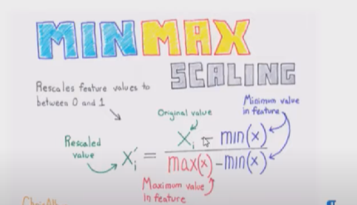
WHEN TO USE FEATURE SCALING
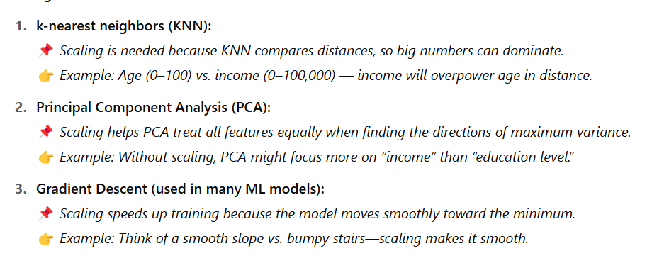
DIFFERENCE BETWEEN NORMALIZATION AND STRADARZATION
✅ Normalization: Scales to [0,1] → Good for distance-based models.
✅ Standardization: Scales to mean 0, std dev 1 → Good for ML models assuming Gaussian-like data.

